EE586

VLSI System Design

Homework 1
20 Pages

Students Participated:

Mohammad Chahardori
Mohammad Ali Mokri

(Due 24th September in class)

Note: The first two problems are for practice purpose, will not be graded. You can work in a group of two students.
- Consider the following circuit
- What is the logic function implemented by the CMOS transistor network? Size the NMOS and PMOS devices so that the output resistance is the same as that of an inverter with an NMOS W/L = 4 and PMOS W/L = 8.
- What are the input patterns that give the worst case t_{pHL} and t_{pLH}. State clearly what the initial input patterns are and which input(s) has to make a transition in order to achieve this maximum propagation delay. Consider the effect of the capacitances at the internal nodes.
- Verify part (b) with Cadence Spectra. Assume all transistors have minimum gate length and you are allowed to run the simulations in any technology node starting from 130 nm and below.
Answer 3) a.
Also we consider the length of transistor equal to minimum length size in 65nm technology:
For NMOS transistors since A and B are parallel and C and D are stacked on each other, also the parallel of A and B is stacked with C and D we have:
On the other hand according to the problem we have:
For the PMOS network, A and B are stacked and C and D are parallel. Also the branch of the A and B is also parallel with C and D. So we have:
The equivalent transistor size for PMOS network when only one branch is active can be calculated as:
On the other hand according to the problem we have:

Therefore:

For NMOS transistor:
For PMOS transistor:
Answer 3) b.
- High to Low Delay
Considering 0 = Logic Low and 1= Logic high = VDD in this problem,
The worst High to Low delay (t_{pHL} ) occurs when A=0, B=1, C=1 and D switch from 0 to 1.
That is because first, for High to Low transition at least one path from output node Y to GND with all transistors in ON region is required (After transition of D, those transistors connected to B, C, D are ON and make this path). Second for the maximum delay only one path from output node Y to GND with all transistors in ON region should exist. Third, when A=0, B=1, C=1 and D=0, those transistors connected to B and C in N network and the transistor connected to A in PMOS network are ON and the transistor connected to D in N network is OFF, as a result all the internal capacitance are connected to VDD through ON transistors and these capacitors are charged to VDD. When D switch from 0 to 1 all these internal capacitance should be discharged through the path consist of NMOS transistors connected to B, C and D.
Also we can say that, since input D in NMOS network has more distant to output node Y it is the slowest input.

- Low to High Delay
The worst Low to High delay (t_{pLH} ) occurs when A=0, B=1, C=1 and D switch from 1 to 0.
That is because first, for Low to High transition at least one path from output node Y to VDD with all transistors in ON region is required (After transition of D the PMOS transistor connected to D becomes ON and make this path). Second for the maximum delay only one path from output node Y to VDD with all transistors in ON region exists. Third, when A=0, B=1, C=1 and D=1, those transistors connected to B and C in N network and the transistor connected to A in PMOS network are ON, as a result all the internal capacitance of all internal nodes are connected to GND through ON transistors and these capacitors are discharged to GND. When D switch from 1 to 0 all these internal capacitance should be charged to VDD through the path consist of PMOS transistors connected D.
Note: Although it may seem that the $B=1→0$ and $C=D=VDD, A=0$ produces the largest delay since B has more distance to the output node (Y), it has less delay because of less parasitic capacitor compared to aforementioned input pattern (A=0, B=1, C=1 and D=1).
Answer 3) c.
In the following figure the schematic of the circuit in cadence software is shown.
Low to high simulation results:
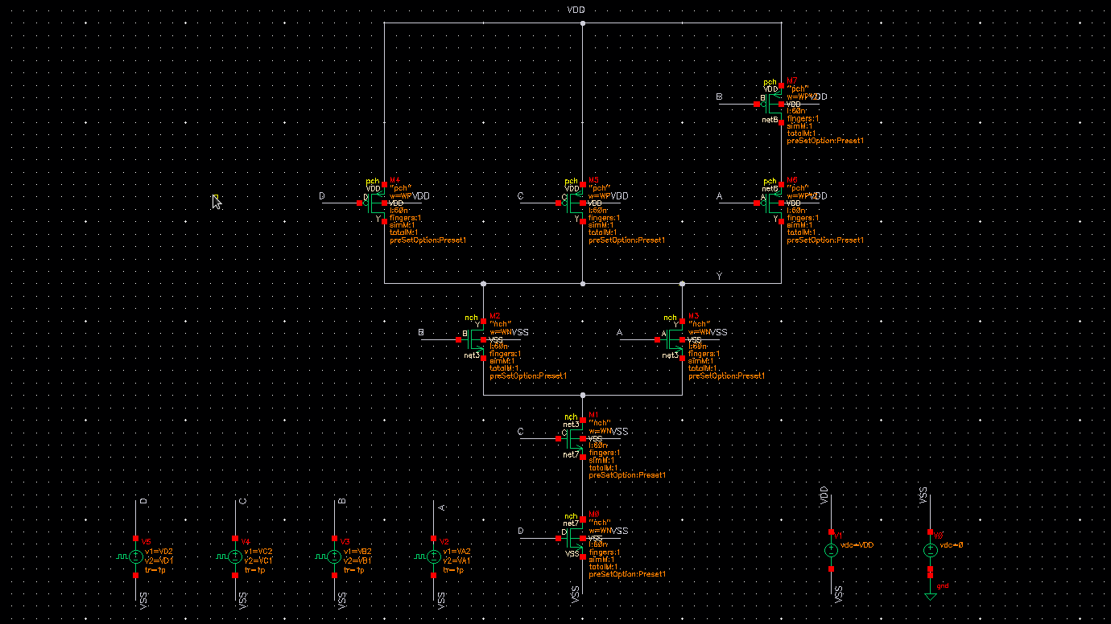
Simulation result of the circuit for 3 different input patterns which cause output high to low transition are shown below:
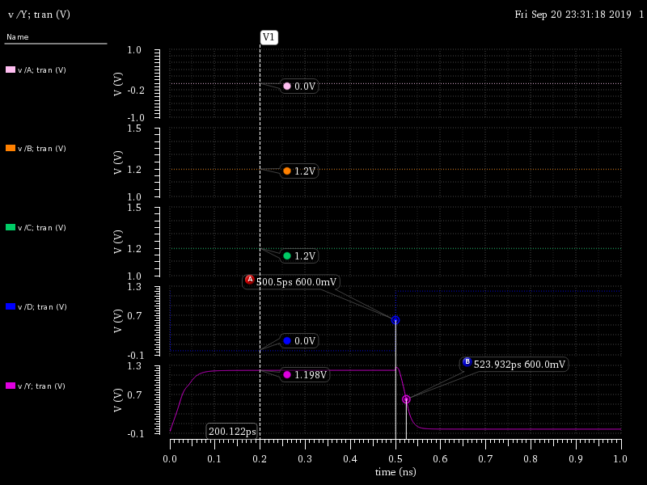
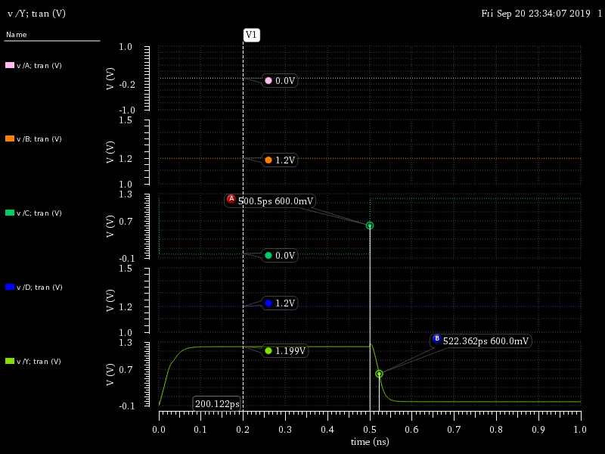
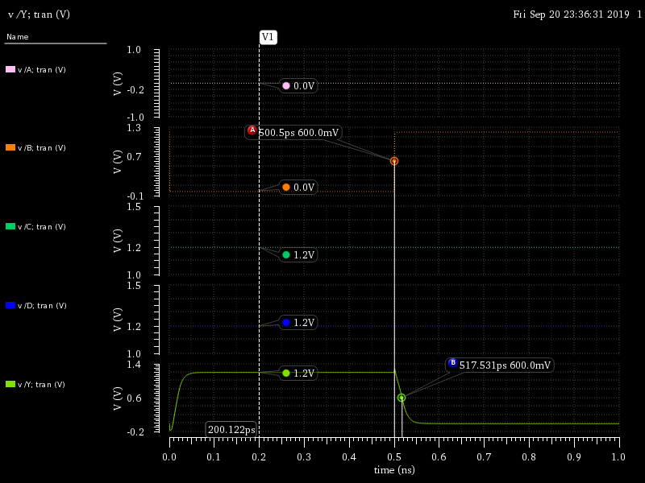
As we can see when A=0, B=1, C=1 and D switch from 0 to 1, the high to low delay is maximum which is 23.93 ps.

Low to high simulation results:
Simulation result of the circuit for 3 different input patterns for low to high transition are shown below:
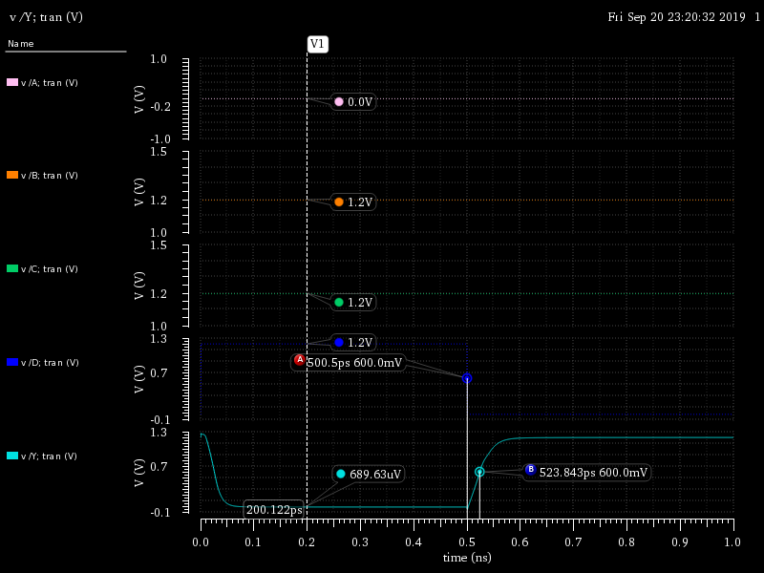
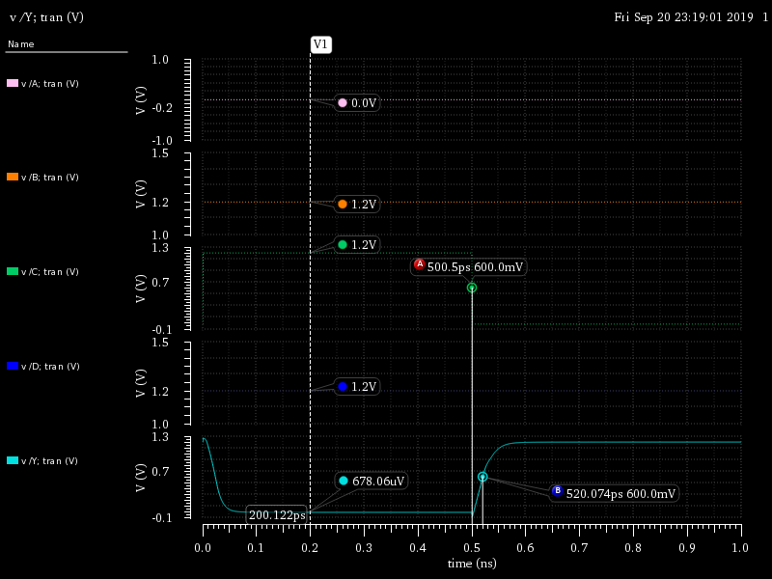
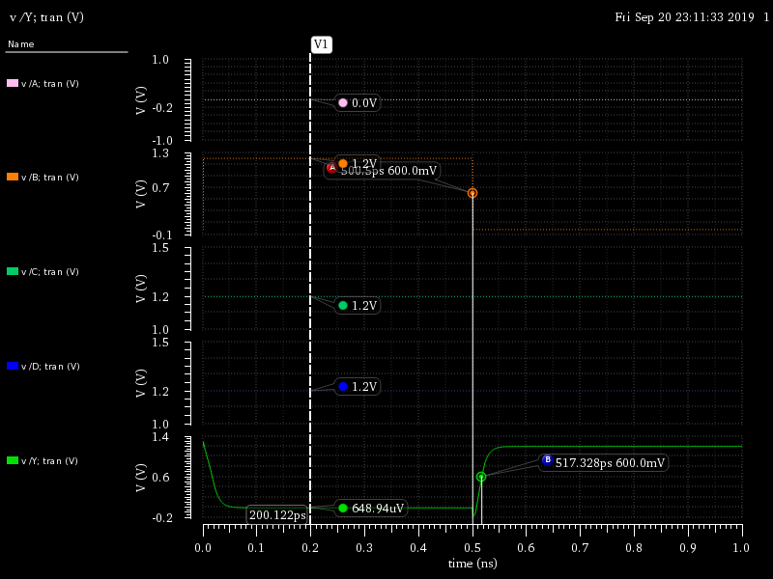
As we can see when A=0, B=1, C=1 and D switch from 1 to 0, the low to high delay is maximum which is 23.84 ps.

- Consider the following two circuits
- Do the following two circuits implement the same logic function? If yes, what is that logic function? If no, give Boolean expressions for both circuits.
- Will these two circuits’ output resistances always be equal to each other?
- Will these two circuits’ rise and fall times always be equal to each other? Why or why not? (Demonstrate through Cadence simulation)
- What input patterns (A–E) give the lowest output resistance when the output is low?
- What input patterns (A–E) give the lowest output resistance when the output is high?
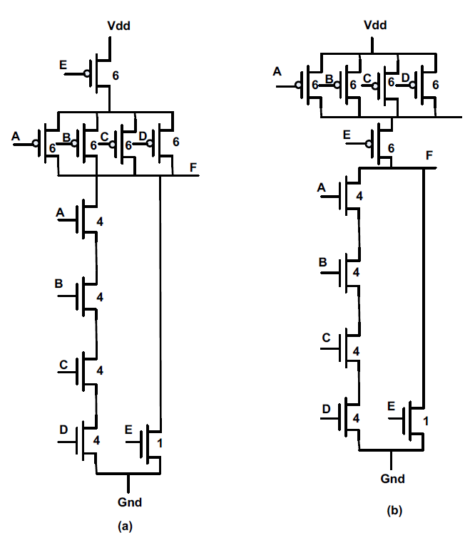

Answer 4. (a)
Both structures have the same logic Boolean expression. The logic function of them is:
Answer 4. (b)
Since both circuits have same logic function and also corresponding transistors in both structures have the same size, the output resistor of the both circuits are equal for all possible input patterns.
Answer 4. (c)
These two circuits have different rise time and fall time. That is because although the output resistance of both circuits are equal, the nodes capacitors which are charged to VDD or discharged to GND during rise time or fall time are different due to different input pattern. For example, when A=B=C=D=0 and E switches from 0 to 1 the output changes from 1 to 0 but the total capacitor which is discharged to GND is different and it is also a function of A, B, C and D input. In the following figure it seems that high to low delay of the output of the structure (a) that is F_a is around 52ps while the high to low output of the structure (b) that is F_b is 12ps which shows that structure (a) is much slower than (b) when A=B=C=D=0 and E switches from 0 to 1. That is because of the effect of internal capacitor of the PMOS network which has been seen in case (a) but it does not have any effect in structure (b) when PMOS transistor connected to E isolates the output nodes from that internal node. In the following figure we see similar occasion for low to high delay as well because of the same reason.
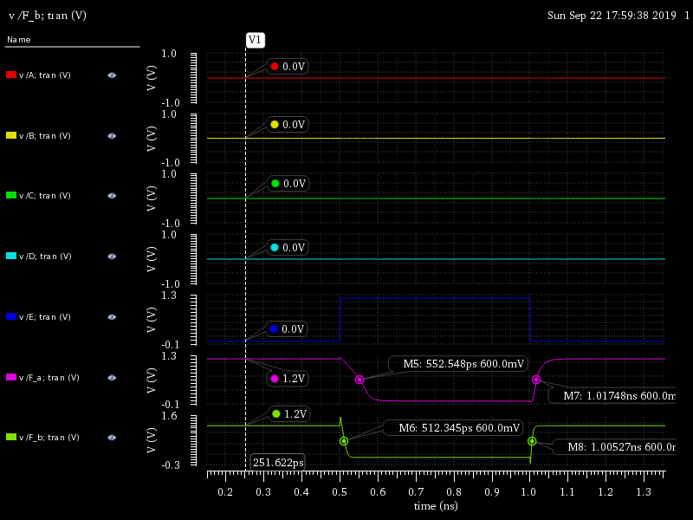

Answer 4. (d)
When the output is low the PMOS network is fully OFF, so it does not have any impact on the output resistance. That means the lowest output resistance for low-output case occurs when the NMOS network has lowest resistance and it happens when all NMOS transistors are ON.

A=B=C=D=E= VDD and consequently all NMOS transistors are ON.
In this case the NMOS network is equal to an NMOS with W=1/2.

Answer 4. (e)
When the output is high the NMOS network is fully OFF, so it does not have any impact on the output resistance. That means the lowest input resistance for output high case occurs when the MOS network has lowest resistance and it happens when all PMOS transistors are ON.

A=B=C=D=E= 0 and consequently all PMOS transistors are ON.
In this case the NMOS network is equal to an NMOS with W=24/5.

5) Determine the sizes of the transistors in the following figure, such that it has approximately
the same tplh and tphl as an inverter with the following sizes: NMOS=W and PMOS=2W (First use
hand calculation and then verify through Cadence simulation)
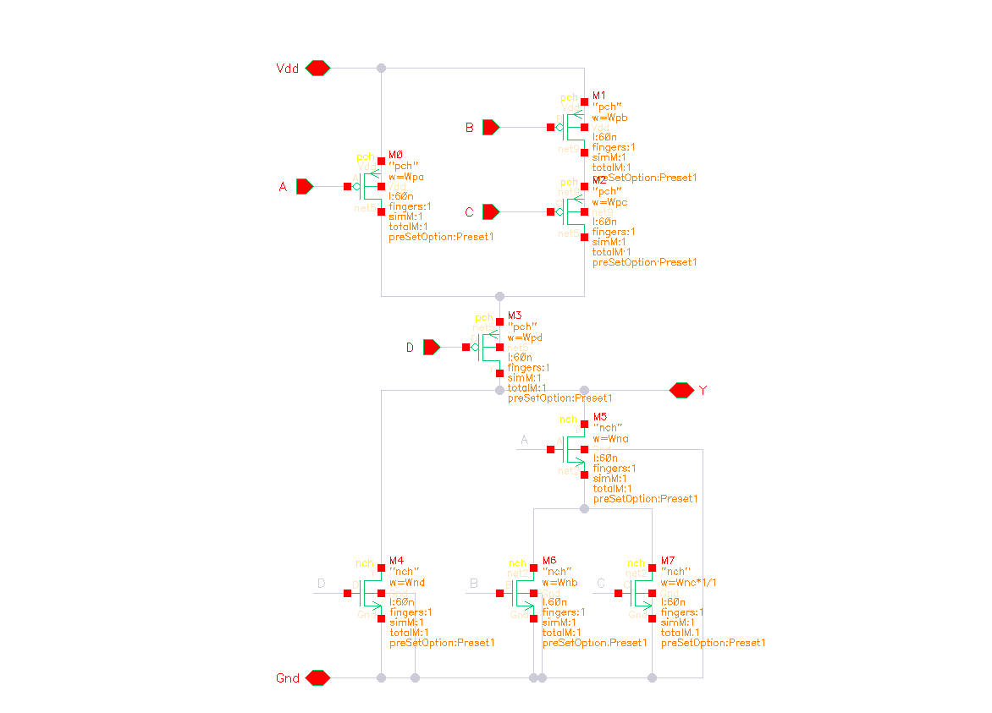
The above figure shows the schematic of the circuit which is going to be designed so that it has the same TPLH and TPHL as an inverter with the given sizes.
We start with hand calculation. If we consider the size of the inverter as: $W_{ninv}$ and $W_{pinv}$. In this case we can make the worst-case resistor path from the $Vdd$ and $Gnd$ to the load in the combinational logic the same as the inverter one to have equal delays. Based on the schematic the path from $Vdd$ to load through $B,C,D$ is the worst path. So, for the Pullup network we should have:
$$R_{eq}∝\frac{1}{W}$$
$$\frac{1}{ReqB}+\frac{1}{ReqC}+\frac{1}{ReqD}=\frac{1}{ReqINV}$$
We can consider simply the same size for the transistor B,C and D. in this case the $W_{pB}=W_{pC}=W_{pD}=3W_{pinv}$.
For the transistor A we have
$$\frac{1}{ReqA}+\frac{1}{ReqD}=\frac{1}{ReqINV}$$
By solving it we have: $W_{pA}=1.5W_{pinv}$
For the Pulldown network B and C has the same condition and both are the in series with A. so the worst case is either B or C are on (not both at the same time) and A is on. $W$
$$\frac{1}{ReqA}+\frac{1}{ReqB }=\frac{1}{ReqINV}$$
$$W_{nA}=W_{nB}=W_{nC}=2W_{nINV}$$
$$W_{nD}=W_{nINV}$$
Now we go to the simulation using the Cadence Virtuoso. We start by the hand calculation.
An inverter with minimum size ($W_{n}=220nm, W_{p}=440nm$) has 4.32pS and 3.78pS fall and rise respectively. Note that the fall delay is slightly higher than the rise delay. This is because the $k_{n}/k_{p}$ ratio for equal rise and fall time in our technology is lower than 2 (about 1.7)
The combinational logic delays using the hand calculation sizes will be 21.24pS and 23.62pS for the rise and fall times.
We can do some optimization on the size of the transistors to get lower delays. In the previous case we simply considered the same size for the stacked transistors. We can consider unequal sizes for the stacked transistors. For example, if we consider transistor D larger than B and C in PMOS stack (the total equivalent resistor kept the same) we can achieve lower delays. After the optimization the rise time and fall would be 20.81pS and 20.2pS, respectively. Even after the optimization, the difference between the inverter and the combinational logic is too high. This is because we balanced the equivalent resistor of the transistors in the combinational logic and the inverter. But the combinational logic has large amount of parasitic capacitor. So, without any load capacitor the delays in this circuit can not be the same. We can consider a load capacitor which models the next stage input capacitor. In practice, there should be a load capacitor which models the next stage. If we add a 10fF load capacitor to the both circuits and try to match the rise and fall times we may make the rise and fall delays of both circuits the same.
The inverter circuit rise and fall times go up to 37.43pS and 35.87pS respectively. For the combinational circuit after upsizing the transistors 3.8 the rise and fall time would be 38.63pS and 37.73pS, respectively. Below is the sizes and variables are used in the circuits.
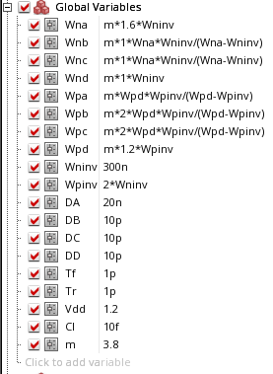
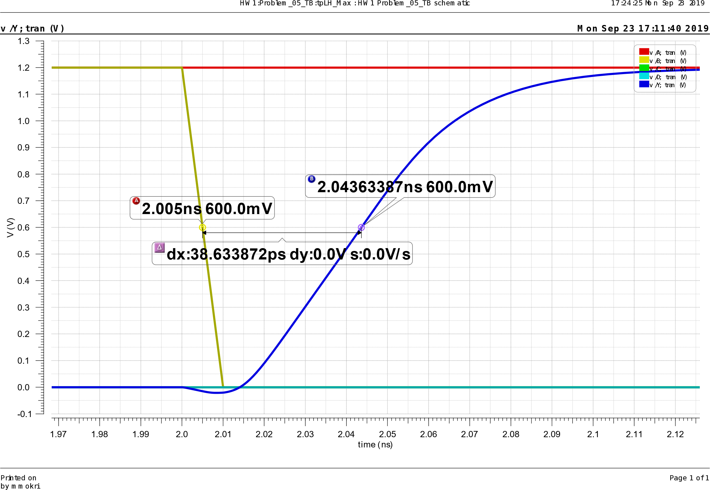
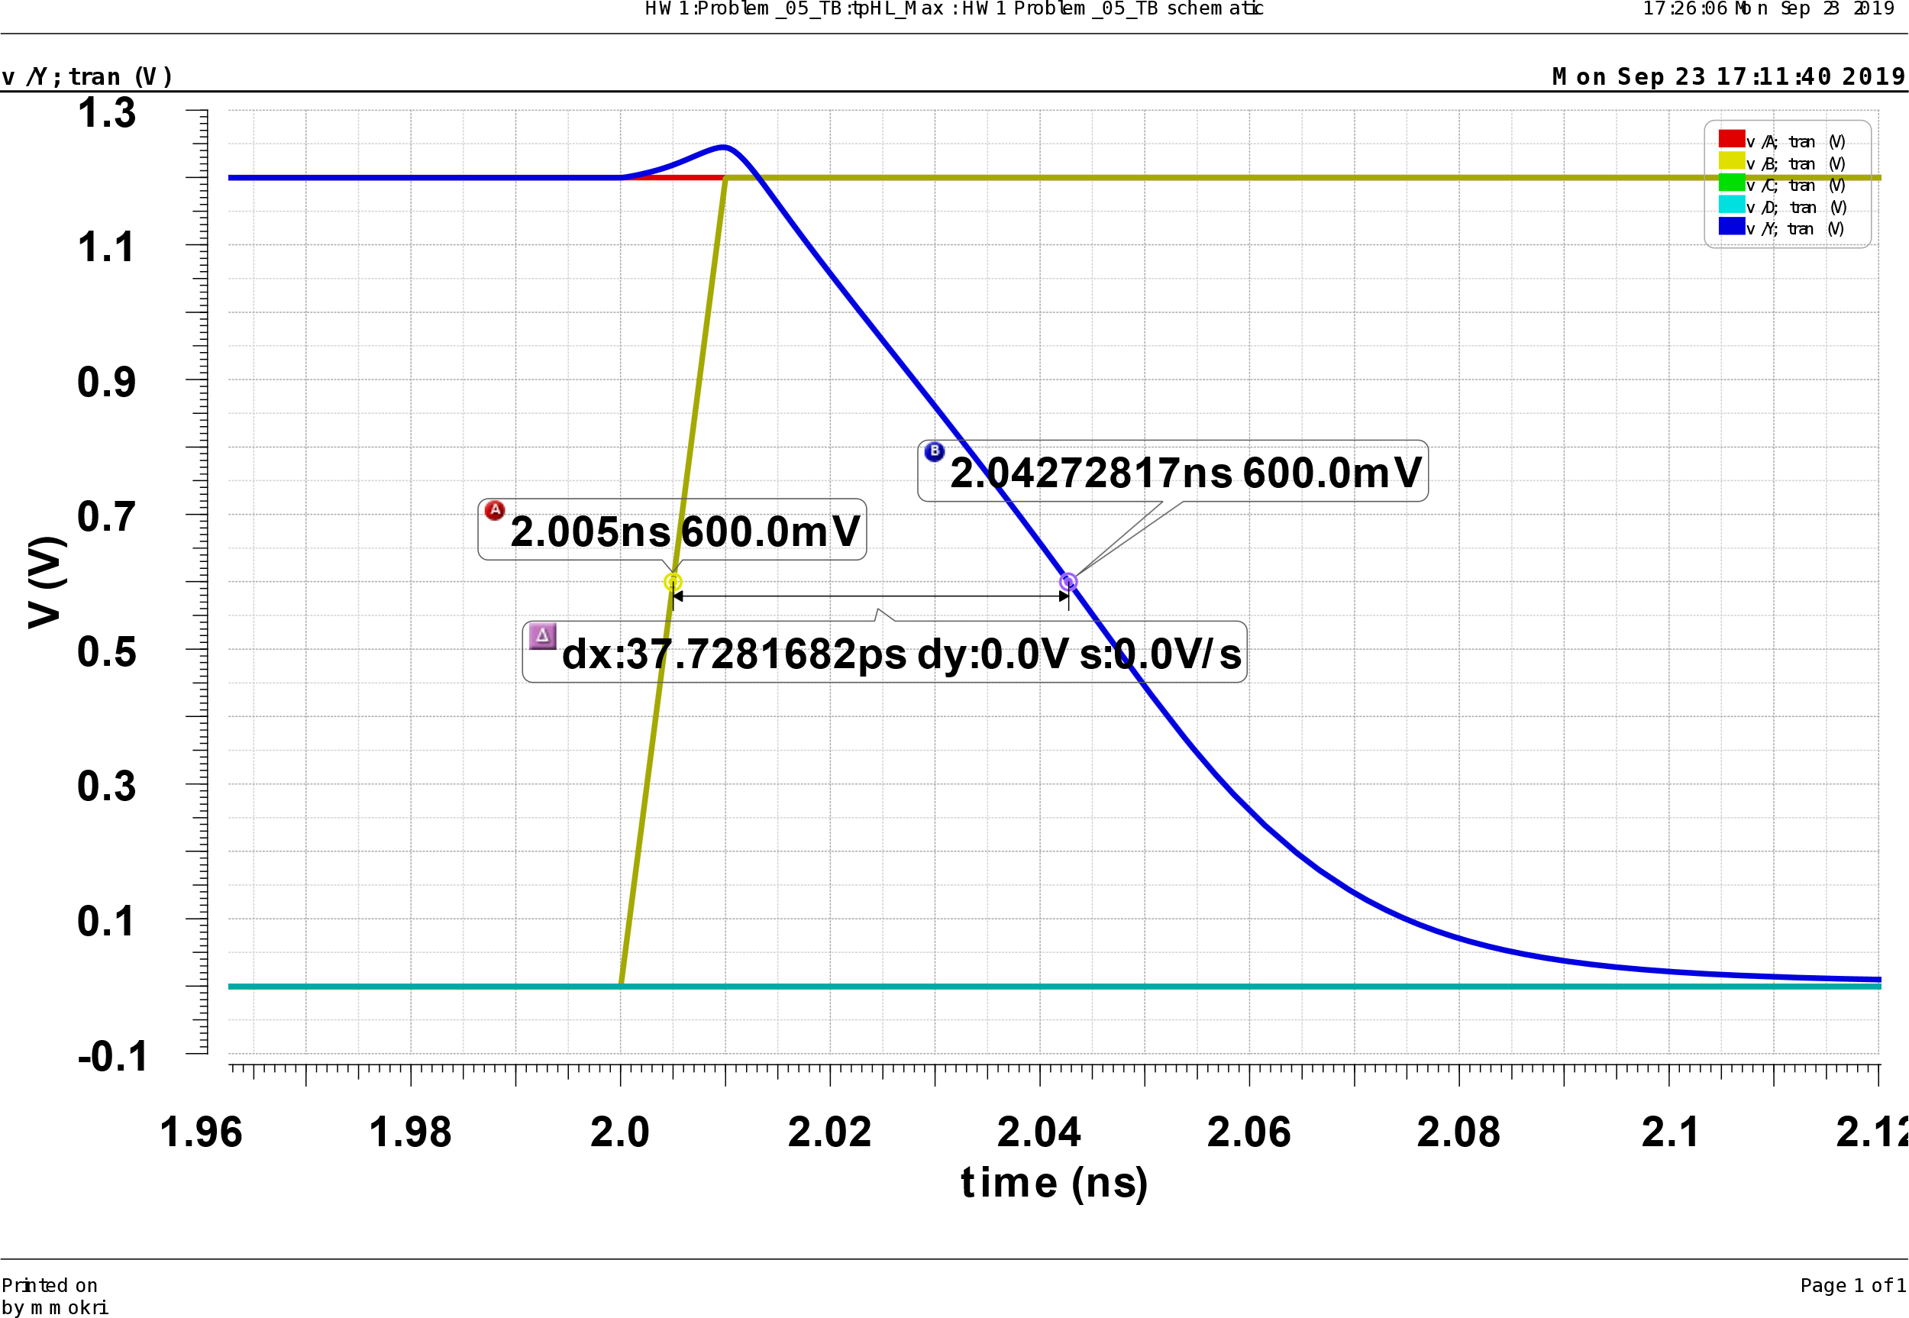
6- Implement the following function as a single stage CMOS gate and a pseudo NMOS gate
$$F=\overline{AB+CD}$$
Determine the size of the transistors for both CMOS and pseudo NMOS gates so that the high-to-low delays in both the cases are equal (use Cadence simulation)

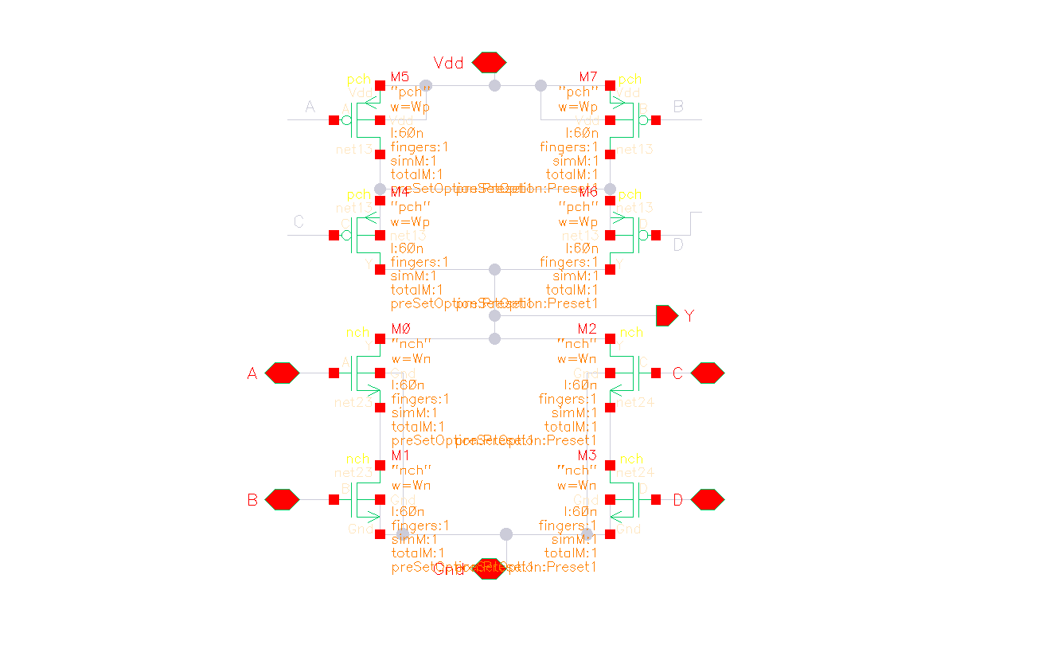 | 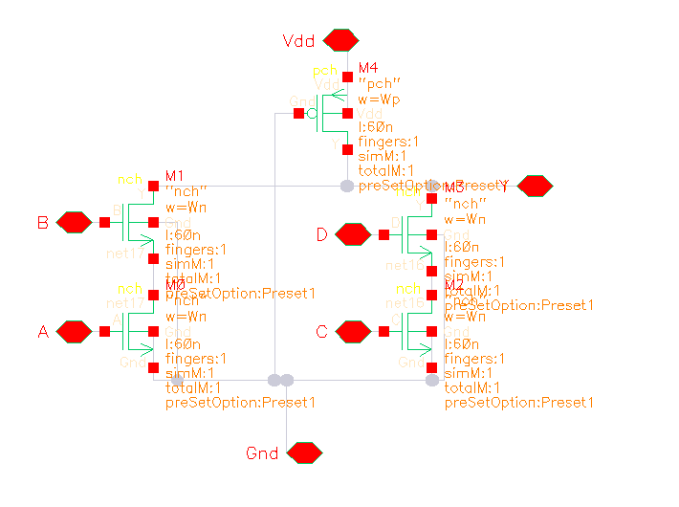
Figure above shows the schematic of the CMOS and Pseudo NMOS implementation of the same function.
We start by sizing the Pseudo-NMOS gate. The largest High to low delay occurs when consider transistor C and D are off and B and A are on. Also, transistor B (higher in stack) turns on before A. in this case we have:
$$I_{dp}=\frac{k_{p}}{2}{\left(Vdd-V_{tp}\right)}^{2}$$
$$I_{dnA}=I_{dnB}=k_{n}\left(Vdd-V_{tn}\right)V_{o}-\frac{1}{2}{\left(V_{o}\right)}^{2}$$
At the steady state $I_{dp}=I_{dnA}$
$$\frac{k_{p}}{2}{\left(Vdd-V_{tp}\right)}^{2}=k_{n}\left(Vdd-V_{tn}\right)V_{o}-\frac{1}{2}V_{o}^{2}$$
As the output goes low ($V_{o}≈0$). We can wright
$$V_{o}=\frac{k_{p}{\left(Vdd-V_{tp}\right)}^{2}}{2k_{n}\left(Vdd-V_{tn}\right)}$$
By this equation we can see that the output voltage is defined by the ratio of the devices. If we take the 150mv as the low output voltage the ration of the NMOS to PMOS should be 2.7.
Now we can move to design of the gates using the Cadence tools. By choosing the minimum size for the PMOS (200nm) and 2.7 times larger for the NMOS transistors the low output voltage is 0.15v and the fall time delay is 10.08pS and the output is around the 155mV.
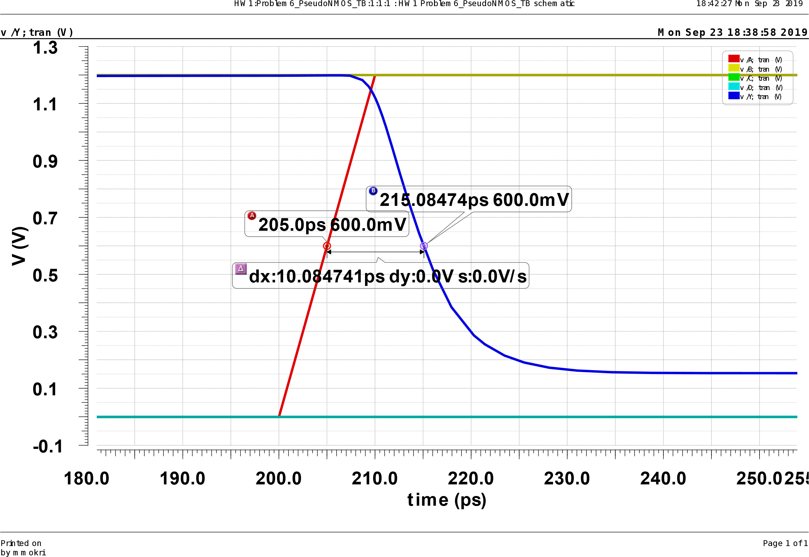
Now we need to design the CMOS implementation. In the CMOS implementation we start by choosing the same size for the NMOS transistor as in the Pseudo-NMOS implementation and double the size of NMOSs for the PMOS transistors. With such sizing the falling delay would be 13pS.
After some optimization on the sizing we can reduce the falling delay to 10.88pS. in this case the NMOS sizes are 800nm and 1200nm for the PMOSs.
